July 25, 2024

**NOTICE OF PUBLIC HEARING**

**ZBZA-2024-0004** An application from Geoffrey J. Ulmer requesting a variance to allow a detached accessory dwelling unit on property less than 10 acres in size, to be located at 1197 N. 400 Road.

Dear Property Owner:

The Douglas County Board of Zoning Appeals will hold a public hearing on the above-referenced request on **Monday, August 19, 2024, at 10:00 A.M**. To view the informational packets, please visit our website at <https://www.dgcoks.gov/>, then select “Boards and Councils,” then select the Board of Zoning Appeals. You can also email [zoning@dgcoks.gov](mailto:zoning@dgcoks.gov) or call 785-331-1343 with any questions you may have.

The meeting will be held in-person at the Public Works/Zoning and Codes Building, located at **3755 East 25th Street, Lawrence, KS**, and via the online videoconferencing platform, Zoom. To participate in the meeting online or over the phone, please follow the instructions on the reverse side of the page.

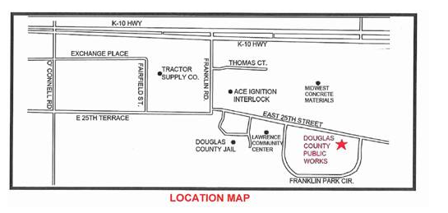

Douglas County’s Zoning Regulations require property owners within a half-mile be notified of an application for a zoning variance. If you have comments about this variance request, you are welcome to attend the public hearing, to have a representative attend for you, or to provide written comment. If you wish to provide written comment, please email [zoning@dgcoks.gov](mailto:zoning@dgcoks.gov) or write to Douglas County Zoning & Codes, 3755 E 25th Street, Lawrence, KS 66047.

Sincerely,

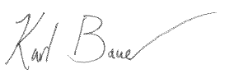

Karl Bauer | County Planner | Zoning & Codes Department

[zoning@dgcoks.gov](mailto:zoning@dgcoks.gov) | 785-331-1343

**Douglas County Z & C is inviting you to a scheduled Zoom meeting.**

**Topic: August 19, 2024 Board of Zoning Appeals Meeting**

**Time: Aug 19, 2024 10:00 AM Central Time (US and Canada)**

**Join Zoom Meeting**

[**https://douglascountyks-org.zoom.us/j/89699437930**](https://douglascountyks-org.zoom.us/j/89699437930)

**Meeting ID: 896 9943 7930**

---

One tap mobile

+13462487799,,89699437930# US (Houston)

+16694449171,,89699437930# US

---

Dial by your location

• +1 346 248 7799 US (Houston)

• +1 669 444 9171 US

• +1 669 900 6833 US (San Jose)

• +1 719 359 4580 US

• +1 253 205 0468 US

• +1 253 215 8782 US (Tacoma)

• +1 646 876 9923 US (New York)

• +1 646 931 3860 US

• +1 689 278 1000 US

• +1 301 715 8592 US (Washington DC)

• +1 305 224 1968 US

• +1 309 205 3325 US

• +1 312 626 6799 US (Chicago)

• +1 360 209 5623 US

• +1 386 347 5053 US

• +1 507 473 4847 US

• +1 564 217 2000 US

Meeting ID: 896 9943 7930

Find your local number: <https://douglascountyks-org.zoom.us/u/kxvgdfMal>