STAFF REPORT

ON AN APPLICATION FOR: A VARIANCE request under the terms of the Zoning and Land Use Regulations for the Unincorporated Territory of Douglas County, Kansas, from J. Dean Grob of Grob Engineering Services, LLC for Glen L. Westervelt of Glenwood LC requesting a Variance to allow gravel surfacing in lieu of the required asphalt or concrete pavement for all off-street parking spaces and access drives for nonresidential uses taking access from adjoining roads paved with asphalt or concrete, to be located at 1749 E 1500 Road.

APPLICANT/OWNER: J. Dean Grob of Grob Engineering Services, LLC, applicant/ Glen L. Westervelt of Glenwood LC, property owners
LOCATION: 1749 E 1500 Road
AREA: 2.02 acres
DATE OF PUBLIC HEARING: July 17, 2023, 10:00 am.
DATE PUBLIC NOTICE PUBLISHED: June 27, 2022
PRESENT LAND USE: LI – Light Industrial District and ASO – Airspace Overlay, used as rental residential, proposed warehouse for a pool business

ASSOCIATED CASE:
- Z-23-00016: Rezoning 2.02 Acres At 1749 E 1500 Road From Ag-2 (Transitional Agricultural) And Li (Light Industrial) Districts To Li (Light Industrial) District
- SP-23-00216: Site plan

SECTION AND REQUIREMENT OF ORDINANCE PERMITTING VARIANCE:
- 12-311-302: Surfacing. Reads in part: “All off-street parking spaces and their access drives required for all (non-residential) commercial and industrial uses shall be paved with an asphalt or concrete surface if the adjoining road is also paved with asphalt or concrete.”

DESCRIPTION OF VARIANCE REQUESTED:
The subject property, 1749 E 1500 Road is approximately 20 acres in size and is developed with a rental residence and a barn structure. The property was previously split-zoned between the Light Industrial and Transitional Agricultural Districts and was recently rezoned so that the entire property is now zoned Light Industrial. The property owner is proposing to construct a warehouse and storage area for a pool business. This is permitted as a “contractor shop and yard,” a permitted use in the Light Industrial District. During the public process for the rezone, several nearby residents commented concerns over stormwater drainage in the area and that would be amplified by a higher density of structures and impervious surfaces. To mitigate this, the applicant is proposing for a portion of the required employee and customer parking be surfaced with gravel. The property takes access from E 1500 Road, a paved road maintained by Douglas County Public Works. There is an existing concrete-surfaced entrance serving the residence that will also serve the proposed warehouse.

VICINITY MAP (IMAGERY: 2022)
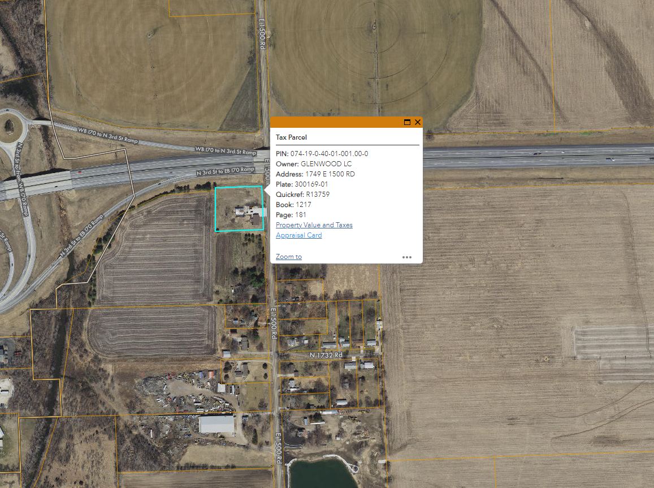

STANDARDS FOR VARIANCES:
- That the variance requested arises from such condition which is unique and which is not ordinarily found in the same zoning district; and is created by this Resolution and not by an action or actions of the property owner or the applicant
Public comment on previous applications related to this property have indicated there are stormwater retention concerns in the area and increasing the amount of structures and impervious surfaces would exacerbate the problem.
- Granting the variance would not adversely affect the rights of adjacent property owners or residents
Part of the intent of the requirement for paving in this situation is to limit the amount of gravel carried onto paved roads, especially from high-traffic commercial and industrial uses. There is an existing concrete-surfaced approach that will be utilized for the warehouse and a portion of the parking, including ADA parking, will be paved. Other nonresidential uses in the neighborhood have gravel driveways and parking areas.
- The strict application of the regulations for which the variance is requested would constitute unnecessary hardship upon the property owner represented in the application
As mentioned, public comment on previous applications related to this property have indicated there are stormwater retention concerns in the area and increasing the amount of structures and impervious surfaces would exacerbate the problem. A gravel parking area would allow water to drain more freely. Requiring additional paved surfaces may constitute an unnecessary hardship.
- The variance desired would not adversely affect the public health, safety, morals, order, convenience, prosperity, or general welfare
A contractor shop and yard is a permitted use in the Light Industrial District. Staff have not identified any adverse impacts to the general public by allowing a portion of the required parking to be gravel-surfaced.
- Granting the variance desired would not be opposed to the general spirit and intent of these Regulations
Part of the intent of the requirement for paving this driveway and parking area is to limit the amount of gravel carried onto paved streets from high-traffic uses. Because the approach and much of the parking will be paved, along with efforts to mitigate drainage concerns, staff find this variance to meet the general spirit and intent of the zoning regulations.

PUBLIC COMMENTS:

As of June 23, 2022, no comments have been received.

AGENCY COMMENTS:
- Pending
STAFF RECOMMENDATION
County Staff recommend approval of the variance request from J. Dean Grob of Grob Engineering Services, LLC for Glen L. Westervelt of Glenwood LC requesting a Variance to allow gravel surfacing in lieu of the required asphalt or concrete pavement for all off-street parking spaces and access drives for nonresidential uses taking access from adjoining roads paved with asphalt or concrete, to be located at 1749 E 1500 Road, with the following stipulations:
- This variance shall apply only to waive pavement standards for a warehouse. Any expansion of the warehouse or addition of other nonresidential uses that increase the parking requirements will require another variance to be obtained from the Douglas County Board of Zoning Appeals;
- The conditions of approval from SP-23-00216 shall continue to be maintained;
- Americans with Disabilities Act parking shall be paved with asphalt or concrete.
Prepared by: Karl Bauer, County Planner
Date: June 23, 2023

APPENDIX I: PARKING SURFACING STANDARDS

12-311-3.02 Surfacing
a. An off-street parking space is an all-weather surfaced area that is not located within a street or alley.
1) All off-street parking spaces and their access drives, including residential, shall be paved with gravel at a minimum.

2) All off-street parking spaces and their access drives required for all (non-residential) commercial and industrial uses shall be paved with an asphalt or concrete surface if the adjoining road is also paved with asphalt or concrete. Said paving shall be completed before the activity or use can commence.

i. This requirement does not apply to over-flow parking (parking in excess of that required for the use, typically for infrequent activities with heavier parking demand).

12-311-3.03 Stormwater Drainage
All off-street parking spaces, and their access drives, shall be planned and engineered to assure proper drainage of surface water. Positive drainage shall be provided on such lot or parcel and discharge of the same shall be through defined drainage courses. No drainage shall be directed over adjoining lands unless approved by the County Engineer.

APPENDIX II: SITE PLAN

See next page

