STAFF REPORT

ON AN APPLICATION FOR: A VARIANCE request under the terms of the Zoning and Land Use Regulations for the Unincorporated Territory of Douglas County, Kansas, from Paul Werner of Paul Werner Architects for Ryan A. and Jennifer B. Schurle requesting a variance to allow a reduction of the required 140-foot front setback to approximately 90 feet for a proposed 80-foot by 50-foot addition to an office and manufacturing building, located at 1837 E 1450 Road.

APPLICANT/OWNER: Ryan A. and Jennifer B. Schurle
LOCATION: 1837 E 1450 Road
AREA: 1.378 Acres
DATE OF PUBLIC HEARING: July 17, 2023, 10:00 am.
DATE PUBLIC NOTICE PUBLISHED: June 27, 2023
PRESENT LAND USE: LI – Light Industrial District, used as offices and manufacturing

SECTION AND REQUIREMENT OF ORDINANCE PERMITTING VARIANCE:
- 12-303-8.04 Dimensional Standards: Requires 60-foot base setback along a principal arterial street and a 80-foot front and exterior side setback.

DESCRIPTION OF VARIANCE REQUESTED:
The subject property is approximately 1.378 acres in size and consists of a building housing a sign business. The property owner is seeking to demolish a portion of the building that extends into the front setback and replace it with a new addition. The new addition is set to be set back further than the building as it stands currently. The building is considered legal-nonconforming, as it was constructed prior to enactment of the current setback requirements.

This property has a variance history. A variance was approved in November 2012 to allow a sign exceeding size limitations.

VICINITY MAPS (2022)
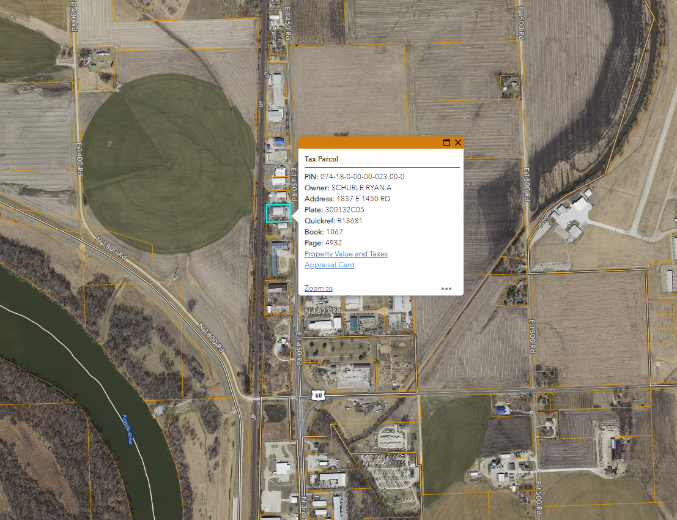
STANDARDS FOR VARIANCES:
- That the variance requested arises from such condition which is unique and which is not ordinarily found in the same zoning district; and is created by this Resolution and not by an action or actions of the property owner or the applicant
The location of existing buildings and the septic system limits the location of an addition to the existing structure. Additionally, the western side of the property is within the regulatory floodplain, and the granting of this variance would allow construction further away from that area.
- Granting the variance would not adversely affect the rights of adjacent property owners or residents
The location of the addition is not anticipated cause any substantial negative impact to the surrounding property owners or hinder any views. The new addition will be set back further from the road than the existing structure set to be demolished.
- The strict application of the regulations for which the variance is requested would constitute unnecessary hardship upon the property owner represented in the application
The location of existing buildings, the septic system, and the presence of floodplain limits the location of where an addition to the existing structure could be built, thus causing an unnecessary hardship.
- The variance desired would not adversely affect the public health, safety, morals, order, convenience, prosperity, or general welfare
The activity taking place of the property is a permitted use in the LI District. Surrounding properties also have LI zoning and have similar uses. Neighboring structures also extend into the front setback.
- Granting the variance desired would not be opposed to the general spirit and intent of these Regulations
The front setback is intended to provide for future road improvements without having to demolish structures, and it is also beneficial for reducing traffic related distractions and incidents. In this instance, the addition will continues to maintain a distance of approximately 90 feet from the center of the road and will be set back further than the existing building. Staff find this variance request to be in alignment with the general spirit and intent of the zoning regulations.
PUBLIC COMMENTS:

As of June 23, 2023, no comments have been received.

AGENCY COMMENTS:

Pending.

STAFF RECOMMENDATION
County Staff recommend approval of the variance request from Paul Werner of Paul Werner Architects for Ryan A. and Jennifer B. Schurle requesting a variance to allow a reduction of the required 140-foot front setback to approximately 90 feet for a proposed 80-foot by 50-foot addition to an office and manufacturing building, located at 1837 E 1450 Road, with the following stipulations:
- This variance shall apply only for a 80-foot by 50-foot addition. Any other structures shall comply with the adopted zoning regulations or another variance shall be obtained from the Douglas County Board of Zoning Appeals.
- All other applicable rules and regulations shall be continually followed.

Prepared by: Karl Bauer, County Planner
Date: June 23, 2023

