STAFF REPORT

ON AN APPLICATION FOR: A VARIANCE request under the terms of the Zoning and Land Use Regulations for the Unincorporated Territory of Douglas County, Kansas, David Stewart of Heartland Propane, requesting a Variance to allow gravel surfacing in lieu of the required asphalt or concrete pavement for all off-street parking spaces and access drives for nonresidential uses taking access from adjoining roads paved with asphalt or concrete, to be located at 296 E 1260 Road.

APPLICANT/OWNER: David Stewart of Heartland Propane, applicant/Heartland Energy, Inc., property owner
LOCATION: 296 E 1260 Road
AREA: 3.36 acres
DATE OF PUBLIC HEARING: July 17, 2023, 10:00 am.
DATE PUBLIC NOTICE PUBLISHED: June 27, 2022
PRESENT LAND USE: GB – General Business District, developed with a propane tank and proposing a garage/storage building.

ASSOCIATED CASE:
- SP-23-00146: Site Plan

SECTION AND REQUIREMENT OF ORDINANCE PERMITTING VARIANCE:
- 12-311-302: Surfacing. Reads in part: “All off-street parking spaces and their access drives required for all (non-residential) commercial and industrial uses shall be paved with an asphalt or concrete surface if the adjoining road is also paved with asphalt or concrete.”

DESCRIPTION OF VARIANCE REQUESTED:
The subject property, 296 E 1260 Road is 3.36 acres in size and is developed with a propane tank. The applicant recently submitted a site plan application seeking to add a storage building to the site, to be used for storing work trucks and supplies related to the propane business. The submitted site plan indicates that the existing gravel driveway that serves the propane tank will remain and will be used to serve the storage building. E 1260 Road is a paved road maintained by Douglas County Public Works. The existing gravel driveway was permitted since the propane tank is not a use that requires parking. A storage building does require parking, and thus the surfacing requirement comes into effect.

Staff is recommending denial as several of the review criteria are not met.

VICINITY MAP (IMAGERY: 2022)
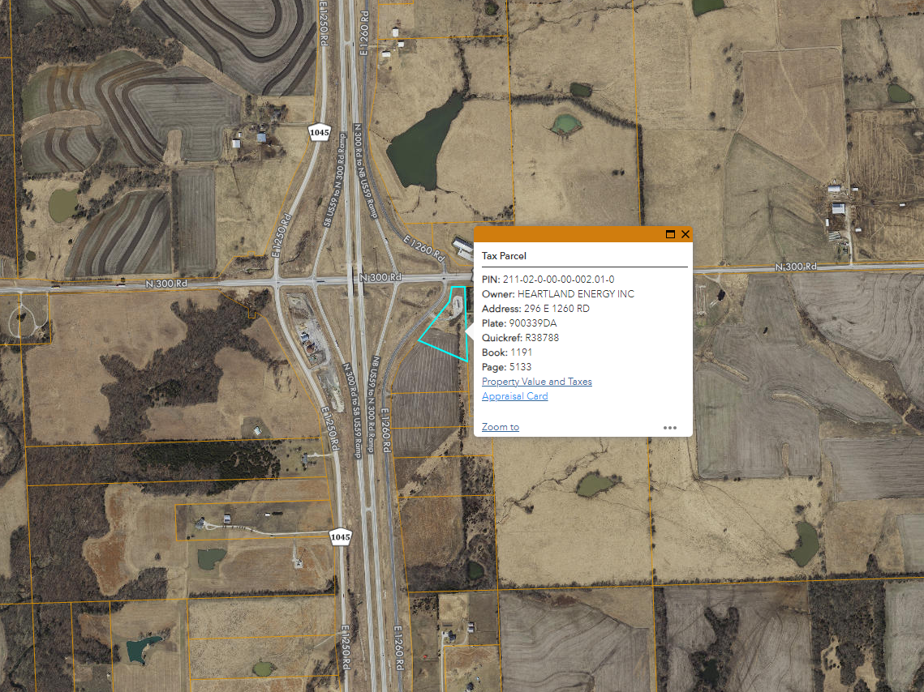

STANDARDS FOR VARIANCES:
- That the variance requested arises from such condition which is unique and which is not ordinarily found in the same zoning district; and is created by this Resolution and not by an action or actions of the property owner or the applicant
Staff has not identified any factor unique to this property that would hinder the paving of the approach and parking. Staff also has not identified any negative impacts that paving the approach and parking would cause. At least two other nearby businesses have paved parking. As such, staff has determined this criterion is not met.
- Granting the variance would not adversely affect the rights of adjacent property owners or residents
Part of the intent of the requirement for paving in this situation is to limit the amount of gravel carried onto paved roads, especially from high-traffic commercial and industrial uses. The applicant has indicated the use will generate minimal traffic and will not be open to the general public. Other nonresidential uses in the neighborhood include a financial institution and a self-storage business, both of which have paved parking.
- The strict application of the regulations for which the variance is requested would constitute unnecessary hardship upon the property owner represented in the application
Staff have not identified an unnecessary hardship concerning the pavement standards and this property. Additionally, in their application, the applicant indicated their request for waiving the pavement standards is based solely on cost: “This is completely a (sic) economic decision for us.” The application states that the Board cannot consider economic hardship when considering a variance request.
- The variance desired would not adversely affect the public health, safety, morals, order, convenience, prosperity, or general welfare
Approval of the site plan for the storage building is pending. As mentioned previously, the site currently has a gravel driveway. Increasing the intensity of the use of the site may generate more gravel being carried onto the paved road which may adversely impact the public health, safety, morals, order, convenience, prosperity, or general welfare.
- Granting the variance desired would not be opposed to the general spirit and intent of these Regulations
Part of the intent of the requirement for paving this driveway and parking area is to limit the amount of gravel carried onto paved streets from high-traffic and commercial/industrial uses. Other variances considered and/or approved regarding the pavement standards have paved at least part of the parking or the apron facing the street. Additionally, a variance previously approved regarding these standards were in agriculturally zoned areas and the variance was considered in an effort to prevent large, paved parking lots in a mostly residential area and to maintain rural character. Unlike that case, this is a much smaller parking area, and the nearby zoning is for commercial and industrial uses. This variance request is to allow for no paving. Staff has determined that this criterion is not met.

PUBLIC COMMENTS:

As of June 23, 2023, no comments have been received.

AGENCY COMMENTS:
- Pending.
STAFF RECOMMENDATION
County Staff recommend denial of the variance request to allow gravel surfacing in lieu of the required asphalt or concrete pavement for all off-street parking spaces and access drives for nonresidential uses taking access from adjoining roads paved with asphalt or concrete, to be located at 296 E 1260 Road.

Should the Board choose to approve the request, staff recommends the following motion:

Approve the variance request from Alan D. Michels, property owner, requesting a Variance to allow gravel surfacing in lieu of the required asphalt or concrete pavement for all off-street parking spaces and access drives for nonresidential uses taking access from adjoining roads paved with asphalt or concrete, to be located at 296 E 1260 Road., with the following stipulations:
- This variance shall apply only to waive pavement standards for a storage building. Any expansion of the storage building or addition of other nonresidential uses will require another variance to be obtained from the Douglas County Board of Zoning Appeals;
- Should SP-23-00146 be denied, this variance shall be considered void;
- The conditions of approval from SP-23-00146 shall be maintained;
- The area stretching from the edge of N 600 Road to the nearest property line shall be paved with asphalt or concrete.
Prepared by: Karl Bauer, County Planner
Date: June 23, 2023

APPENDIX I: PARKING SURFACING STANDARDS

12-311-3.02 Surfacing
a. An off-street parking space is an all-weather surfaced area that is not located within a street or alley.
1) All off-street parking spaces and their access drives, including residential, shall be paved with gravel at a minimum.

2) All off-street parking spaces and their access drives required for all (non-residential) commercial and industrial uses shall be paved with an asphalt or concrete surface if the adjoining road is also paved with asphalt or concrete. Said paving shall be completed before the activity or use can commence.

i. This requirement does not apply to over-flow parking (parking in excess of that required for the use, typically for infrequent activities with heavier parking demand).

12-311-3.03 Stormwater Drainage
All off-street parking spaces, and their access drives, shall be planned and engineered to assure proper drainage of surface water. Positive drainage shall be provided on such lot or parcel and discharge of the same shall be through defined drainage courses. No drainage shall be directed over adjoining lands unless approved by the County Engineer.

APPENDIX II: SITE PLAN
